Moreover, with comparable ranges and different processes, there was also an urgent need to improve efficiency by, among other things, standardising processes. As there was no room for further expansion at the current location, it was decided to build a new building in the centrally located Bleiswijk. The various logistical processes are to be brought together here within a year. This will be a considerable challenge given the fact that the existing deliveries have to continue every day. Ctac has helped Mediq in bringing about this improvement in quality with more efficient working methods and the setting up of new processes.

# Medical devices for thousands of patients in the Benelux

Mediq, which has its head office in Utrecht, is a market leader in twelve countries. The company was founded in 1899 and employs about 3,000 people. The products Mediq delivers range from medical devices for chronic patients, such as people with diabetes or a stoma, to equipment for respiratory care, infusion therapy and medical nutrition for more vulnerable patient groups, as well as to all kinds of products that a large hospital or care institution may need every day. It goes without saying that the logistics of this must be extremely accurate, reliable and punctual.

**IN 1.5 YEARS, MEDIQ MOVED**

**FROM FIVE DISTRIBUTION**

**POINTS TO ONE FULFILMENT**

**CENTRE.**

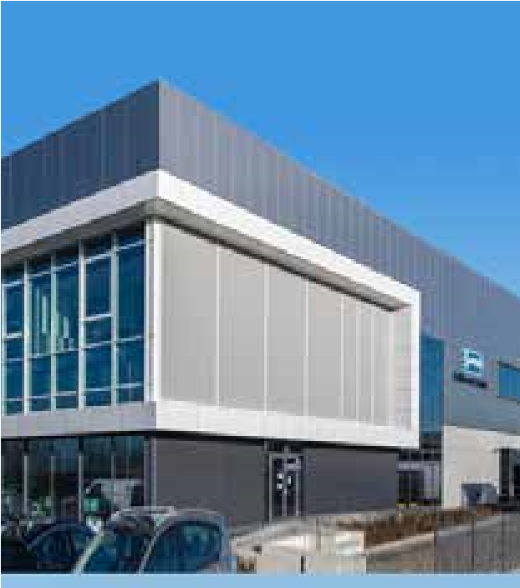

Mediq is a major player in Europe in the sector of medical devices, total logistics

solutions and care innovation. It delivers to the B2B channel, such as healthcare

facilities, hospitals and primary care facilities, as well as directly to the patient, also

referred to as the end user. Why this change? The capacity of the former five

distribution centres in the Benelux was too limited and no longer met the standards.



# Major change that the customer is not supposed to notice

Tony Webster, Group Director Supply Chain

Development at Mediq, faced a major challenge about 1.5 years ago. In order to achieve the desired improvement in quality, the plan was to dismantle the five existing distribution centres in phases and eventually bring them together in the new Fulfilment Centre in Bleiswijk. Tony Webster: “It obviously had an enormous impact on the entire organisation. With this exercise, we had to tackle our omni-channel approach and integrate both the direct and the indirect channels. In addition, of course, the business had to continue as you can’t afford to allow customers to be inconvenienced by the change.” All logistics data flows arrive via a single SAP process and then need to be translated into different products, packaging and types of customers. “In the case of a healthcare institution, for example, we talk about outer boxes containing sets of various products, while in the case of a private patient, it is a single product. That sounds simple but, with so many different productmarket combinations the number of variables – and thus the amount of data – is gigantic. For a large proportion

of our orders, it is a case of: ordered today, delivered tomorrow.”

# A well thought-out process and the right specialists are half the battle

Mediq already knew Ctac as a subcontractor from an earlier SAP job. Now Mediq Warehouse Management was looking for SAP consultants with a knowledge and experience of warehouse processes and warehouse mechanisation. And that is why he went back to Ctac.

“We set up the change process right away”, says Tony. “It was a steering committee of four people: a project leader for the IT (Ctac counterpart), the project manager and a steering group member from Ctac and myself. This way, we ensured everyone adhered to the agreements and kept an eye on the hours.” The essential was to integrate the SAP Warehouse Management, Pick to Light and the Order Storage Retrieval Shuttle from KNAPP. Ctac explicitly looked for ways to develop the entire automation process using the KNAPP layout in order then to implement it using smart processes. A deliberate choice was made to work according to the standard as much as possible so as not to reinvent the wheel and to incorporate as many guarantees as possible so as to have a smooth process. More than 20,000 order processing messages may be sent between KNAPP and SAP every day. In order to streamline this, use has been made of the SAP interface messages. Various customer-specific processes have also been set up. In this way, Mediq is able to structure the orders that come in from different sides properly.

**CTAC THE NETHERLANDS**

Meerendonkweg 11, Postbus 773

5201

AT ’s-Hertogenbosch

T.

+31 (0)73 692 06 92

E. info@Ctac.nl

www.Ctac.nl

I.

**CTAC BELGIUM**

Uilenbaan 82

2160

Wommelgem

T.

+32 (0)3 354 09 79

E. info@Ctac.be

I.

www.Ctac.be

Ctac N.V. 2019, all rights reserved. No part of this publication may be

reproduced and/or made public by print, photocopy, microfilm, or in any

other way, or stored in a databank or retrieval system without the written

permission of Ctac N.V.

**A successful partnership with the desired end result** The collaboration was a real partnership and the process ran the way Mediq wanted it to do. Within schedule and budget. Tony Webster is very positive: “Ctac’s SAP WM specialists, in particular, and their process knowledge of warehouse processes, including the mechanisation aspects involved, were of great added value.” Apart from the IT technical challenges, for Mediq it was also a condition that the migration steps take place in such a way that customers would not notice anything. “So before we went live, there had to be extensive testing as well. Apart from an excellent process and the great flexibility shown by Ctac, the end result was what we had in mind. At the beginning, we defined a business case together which has since been realised and we are working on tightening up our processes even more every day.”